Studio Web Access

1. To access UiPath Studio Web, you will need to create an account and log into <https://cloud.uipath.com>



Note: If you have UiPath account already then login with available options else create an account by clicking on **Sign up** option.

1. Enter Login details here



1. Enter Full Name, Country and State details here.



1. Enter Organization name here. Ex. MyOrganization.

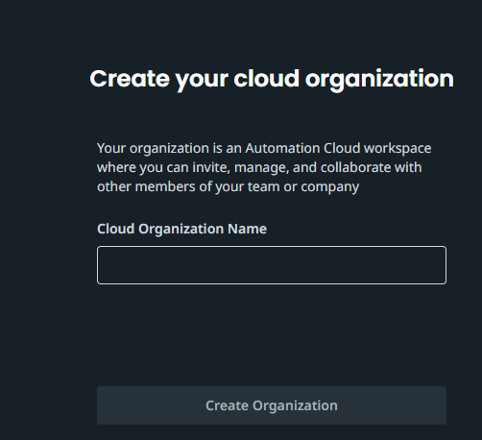

1. It will take couple of minutes to set-up your account and then you will be landed to below page. **UiPath Studio Web** available on the left hand side menu. Click on it.

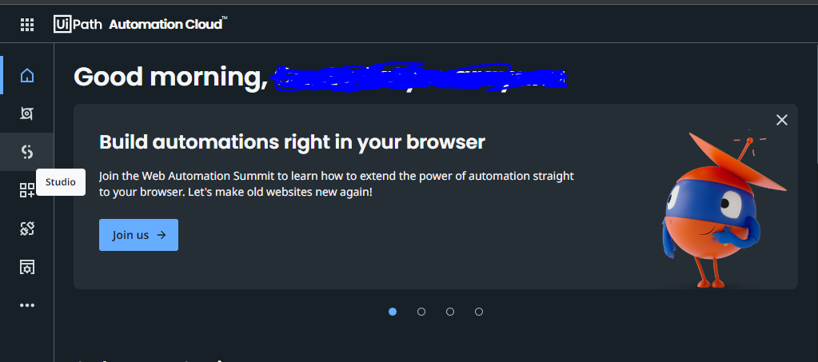

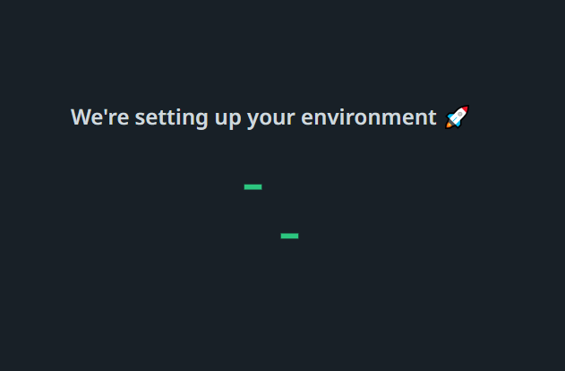

1. Click on Next and then click on Let’s Go.

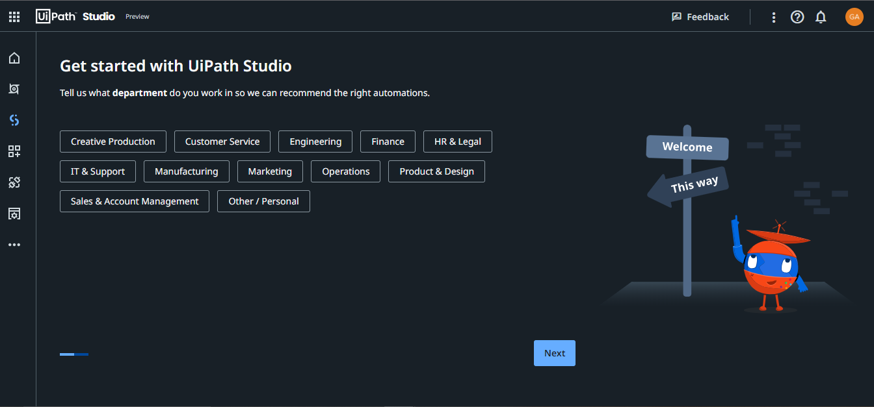

1. Finally you will be ended up to below page. Where we can create new projects and use of it.

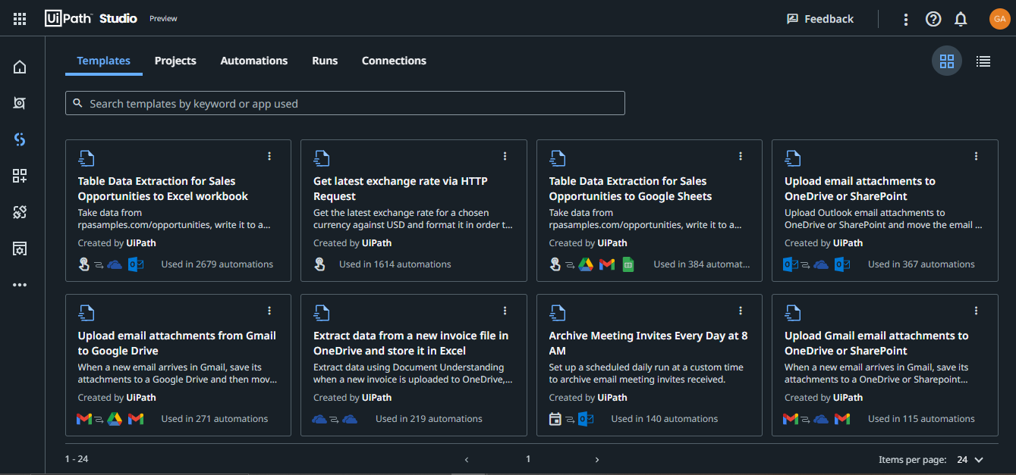

**Templates:** UiPath providing us different templates. We can customize any of the existing templates to match our needs.

**Projects:** Here, We will create our business processes.

**Automations:** Published projects will be shown up here.

**Runs:** We can find current running processes here.

**Connections:** All integrated services connections will be find here.